**Практика.  
Прочтите требования и проанализируйте их:**

**Settings/Functions on the “Create View” Page**

* “Report View Name” → sets Report View displayname for the roles: FirmManager and Advisor.
  + Text box
  + Character limit = 255
  + Validation: once user clicks outside of “Report View Name” textbox, validate displayname character count <= 256
    - If Fails validation, then display red border around text box
* Radio Icon “Report Type” component with options for Firm Report / Client Report → sets Report View viewcontext
* Radio Icon “Format” component with options for CSV / PDF/ XLS → sets Report View format
* Radio Icon “Orientation” component with options for Landscape/Portrait → sets Report View orientation
  + IF ReportView format = PDF, then show Orientation component only for FirmManager.
  + Else hide Orientation component
* Button: “Create View”
  + “Create View” is greyed out and not clickable unless:
    - displayname is not null
    - viewcontext is not null
    - format is not null
    - IF format = PDF, then orientation is null
  + Upon click, attempts to create and save Report View object
    - Save Validation: upon save, validate that displayname must be unique within firm
      * If Fails validation, then display red border around text box and prevent save
    - Save Validation: upon save, validate that displayname character count <=255
      * If Fails validation, then display red border around text box and display message:
  + Upon successful save by clicking Save button, takes you to Report Builder Page.

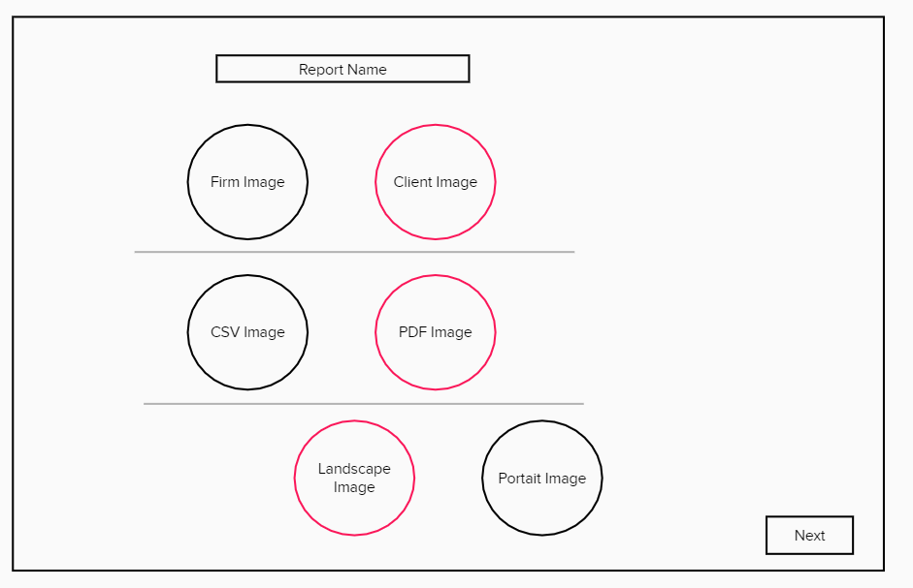  
  
**3 User Stories:**

1. As an Adviser I want to have an appotuniity of choice formats like PDF, CSV and XLS, so I can use different documents.

2. As a FirmManager I want to click “Save button”, so I can take to Report Builder Page.

3. As an Adviser I want to input text in “Report View Name”, so I can validate to uniqe and charcter limit <=255